St. Mary Parish
2017-18 Faith Formation Parent Information

Welcome!
It is a great privilege to be a part of your children’s faith formation. What a gift it is to give your children the opportunity to grow in the knowledge of the love of God. As parents, YOU are the primary educators of your children in our Catholic faith. At St. Mary Parish we hope to guide and support you along the way. Our faith formation program strives to develop spiritual values, deepen the children’s relationship with our loving God, increase their knowledge of faith and Church, enrich their prayer practices and provide opportunities to serve their community. This is also a wonderful opportunity for you to grow in faith alongside your children!

What does it mean to be a “primary educator”?
Being the primary educator of your child’s faith formation is a responsibility you accepted at their Baptism. Please stay involved in your child’s faith formation! Let your child see that you are engaged and eager to learn alongside them. Support your child’s teacher by letting them know you are willing to be partners with them in any way possible. Make faith formation a lifelong commitment by continuing to learn about your own faith and by attending Mass weekly. Share with your child your time, your attention, your knowledge and your love—in this way you will model what it means to be loved, just as God loves your child. Don’t forget to pray, participate, laugh and enjoy!

Program Overview
Our traditional Faith Formation program for kindergarten through eighth grade uses a curriculum which is approved by the Diocese of Sacramento. This traditional Faith Formation program fosters a lifelong relationship with God by engaging children in the full and authentic teachings of the Catholic Church. Weekly classes are one hour and are offered on Wednesday from 6:00-7:00pm beginning early September through May. All of our classes are taught by volunteers.
First Eucharist and Reconciliation are traditionally celebrated at the end of 2nd grade. Sacramental preparation begins in the 1st grade and enrollment is required during both years of this two-year preparation time period. Confirmation is celebrated at the end of 8th grade. Sacramental preparation begins in 7th grade and enrollment is required during both years of this two=year preparation time period.

Curriculum
- Pflaum: (K-8th) The lectionary-based program, in addition to Sacrament Preparation resources for Year 2, is a wonderful way to learn more about the Bible and the readings for Sunday’s mass. The curriculum will be for the Sunday following classes, so your child will be familiar with the readings at Mass. Pflaum offers many expanded activities that your student(s) will be using in class. Family resources can be found under “Free Online Resources”, located on the left sidebar of the main page of Pflaum.com.

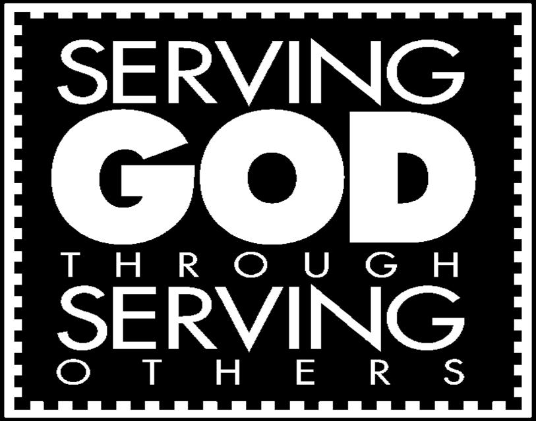
Service Projects
Our efforts in service to one another demonstrate our Catholic Social Teaching in caring for the human spirit and the dignity of each person. As an overall continuous service project, we encourage families to donate items for our St. Vincent de Paul Food Closet or Maryhouse each month.

(continued on reverse)

Parent Responsibilities
As a parent, you model your faith for your children daily. We ask you to:
- Ensure that your child attends class regularly and is on time. We look for students to not miss more than three class sessions in a school year. For any absences, please make arrangements with your child’s Catechist to get the lesson(s) that they have missed. This is very important, especially in sacrament years, to ensure they are prepared thoroughly. Excessive absences could cause delay of the sacraments.
- Drop off your child no more than 10 minutes prior directly to the room. Due to safety regulations, there is no use of the playground allowed.
- Be an active part of your child’s faith formation experience!
- Attend mass weekly as a family. Faith Formation classes do not take the place of attending mass!
- Communicate with your child’s Catechist any special needs or circumstances.
- Stay involved in the parish through parish activities.

Student Behavior Expectations
St. Mary Parish is committed to providing a safe, nurturing environment for participants in our Faith Formation programs. We are very fortunate to have a strong group of volunteer Catechists and Aides who set aside time each week to share their faith with the children of our parish. In order for our program to proceed effectively each week it is important that every child be attentive, respectful and on task. Catechists will work closely with their students to be a positive example, be fair and consistent, and to be compassionate to meet the needs of all involved.
- Guidelines for Appropriate Student Behavior
- Be respectful of one another and shared spaces with the school. All items in the classroom should be respected and left alone.
- Be responsible for your actions.
- Make safe choices.
Students will receive a verbal warning for the first misbehavior. If the misbehavior continues the Catechist
will work together with the parents to correct the problem. Parents may be asked to attend the Faith
Formation class with their child to assist in maintaining appropriate behavior and a positive learning
environment. We also ask for no “Heelies” in the classroom.

Arrival and dismissal
Kindergarten through sixth graders must be delivered and picked up to/from their classroom by an adult, and must be signed in and out of their class. Parents are not required to escort their seventh and eighth grade students to and from their classroom. All students should use the restroom before class begins.
Our Catechists have prepared a weekly lesson and will start and end class on time. It is disruptive if students are arriving late or are leaving class earlier than the regular dismissal time. Please be considerate of the one hour dedicated each week to the faith formation classes for your child(ren). Lastly, we ask that children are picked up and taken home as soon as class is over so that the school buildings can be secured in a timely manner. Thank you!

A Parent’s Prayer
Loving God, You are the giver of all we possess, the source of all of our blessings. We thank and praise you. Thank you for the gift of our children. Help us to set boundaries for them and yet encourage them to explore. Give us the strength and courage to treat each day as a fresh start. May our children come to know you, the one true God, and Jesus Christ, whom you have sent. May your Holy Spirit help them to grow in faith, hope and love, so they may know peace, truth and goodness. May their ears hear your voice. May their eyes see your presence in all things. May their lips proclaim your word. May their hearts be your dwelling place. May their hands do works of charity. May their feet walk in the way of Jesus Christ, your Son and our Lord. Amen.

